**NEWS TRACKER APPLICATION** **TEAM ID :** PNT2022MID49399

[**SETTING UP APPLICATION ENVIRONMENT**](https://careereducation.smartinternz.com/Student/guided_project_workspace/7918#collapse1)

# Create Flask Project

Six Steps have been followed to create Flask Project.

The Steps that we have followed have been described below

**Step 1:**

Install Python latest version from python.org

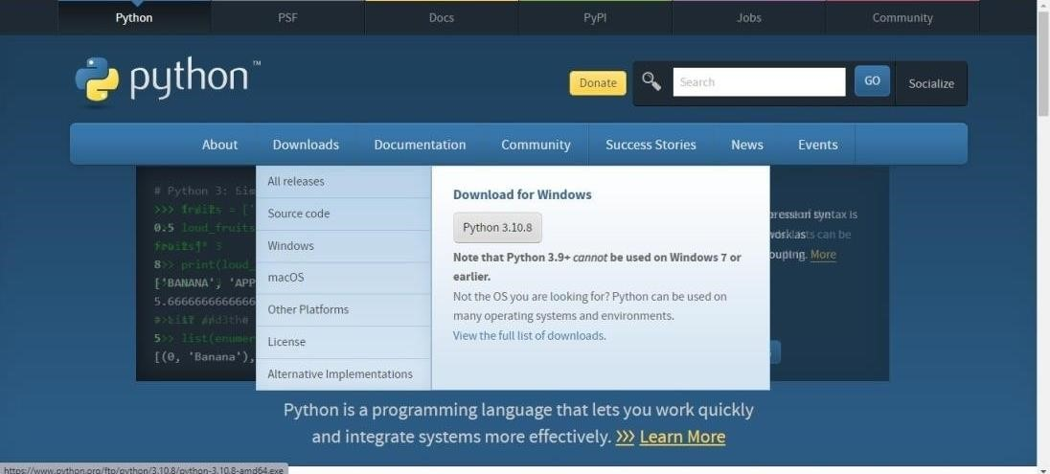

**Step 2**:

Download Anaconda from https://[www.anaconda.com/](http://www.anaconda.com/) and install it byrunning the .exe file



## NEWS TRACKER APPLICATION TEAM ID : PNT2022TMID49399

**Step 3**:

Install Flask using command pip install flask

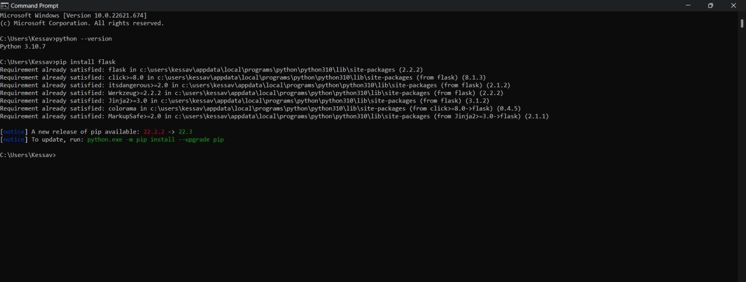

**Step 4.**

Open a new Python file and start coding from flask import

Flask app = Flask( name )

@app.route('/')

def hello(): return “Hello World” if name == ' main

': app.run(debug=True)

**Step 5 .**

Open the Ip in browser

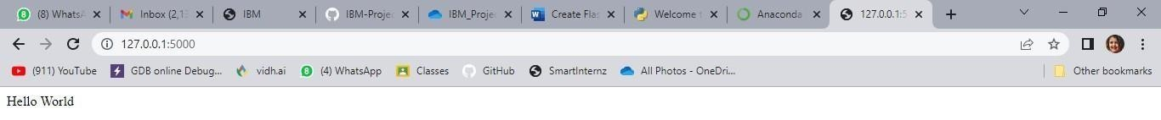

**OUTPUT**

IBM Cloud CLI is installed successfully.